Prototype 1 testing
BLE + LED model

Test 1
- We just wanted to verify that we could set up a BLE server and connect to it from a phone
- Used the built-in LED on the esp32 dev board to verify connection
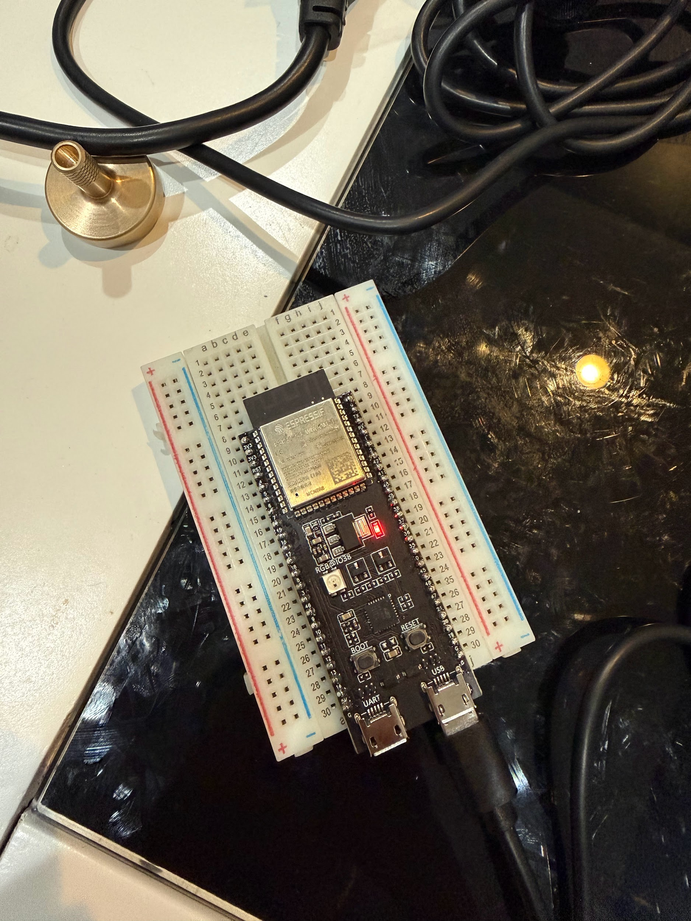
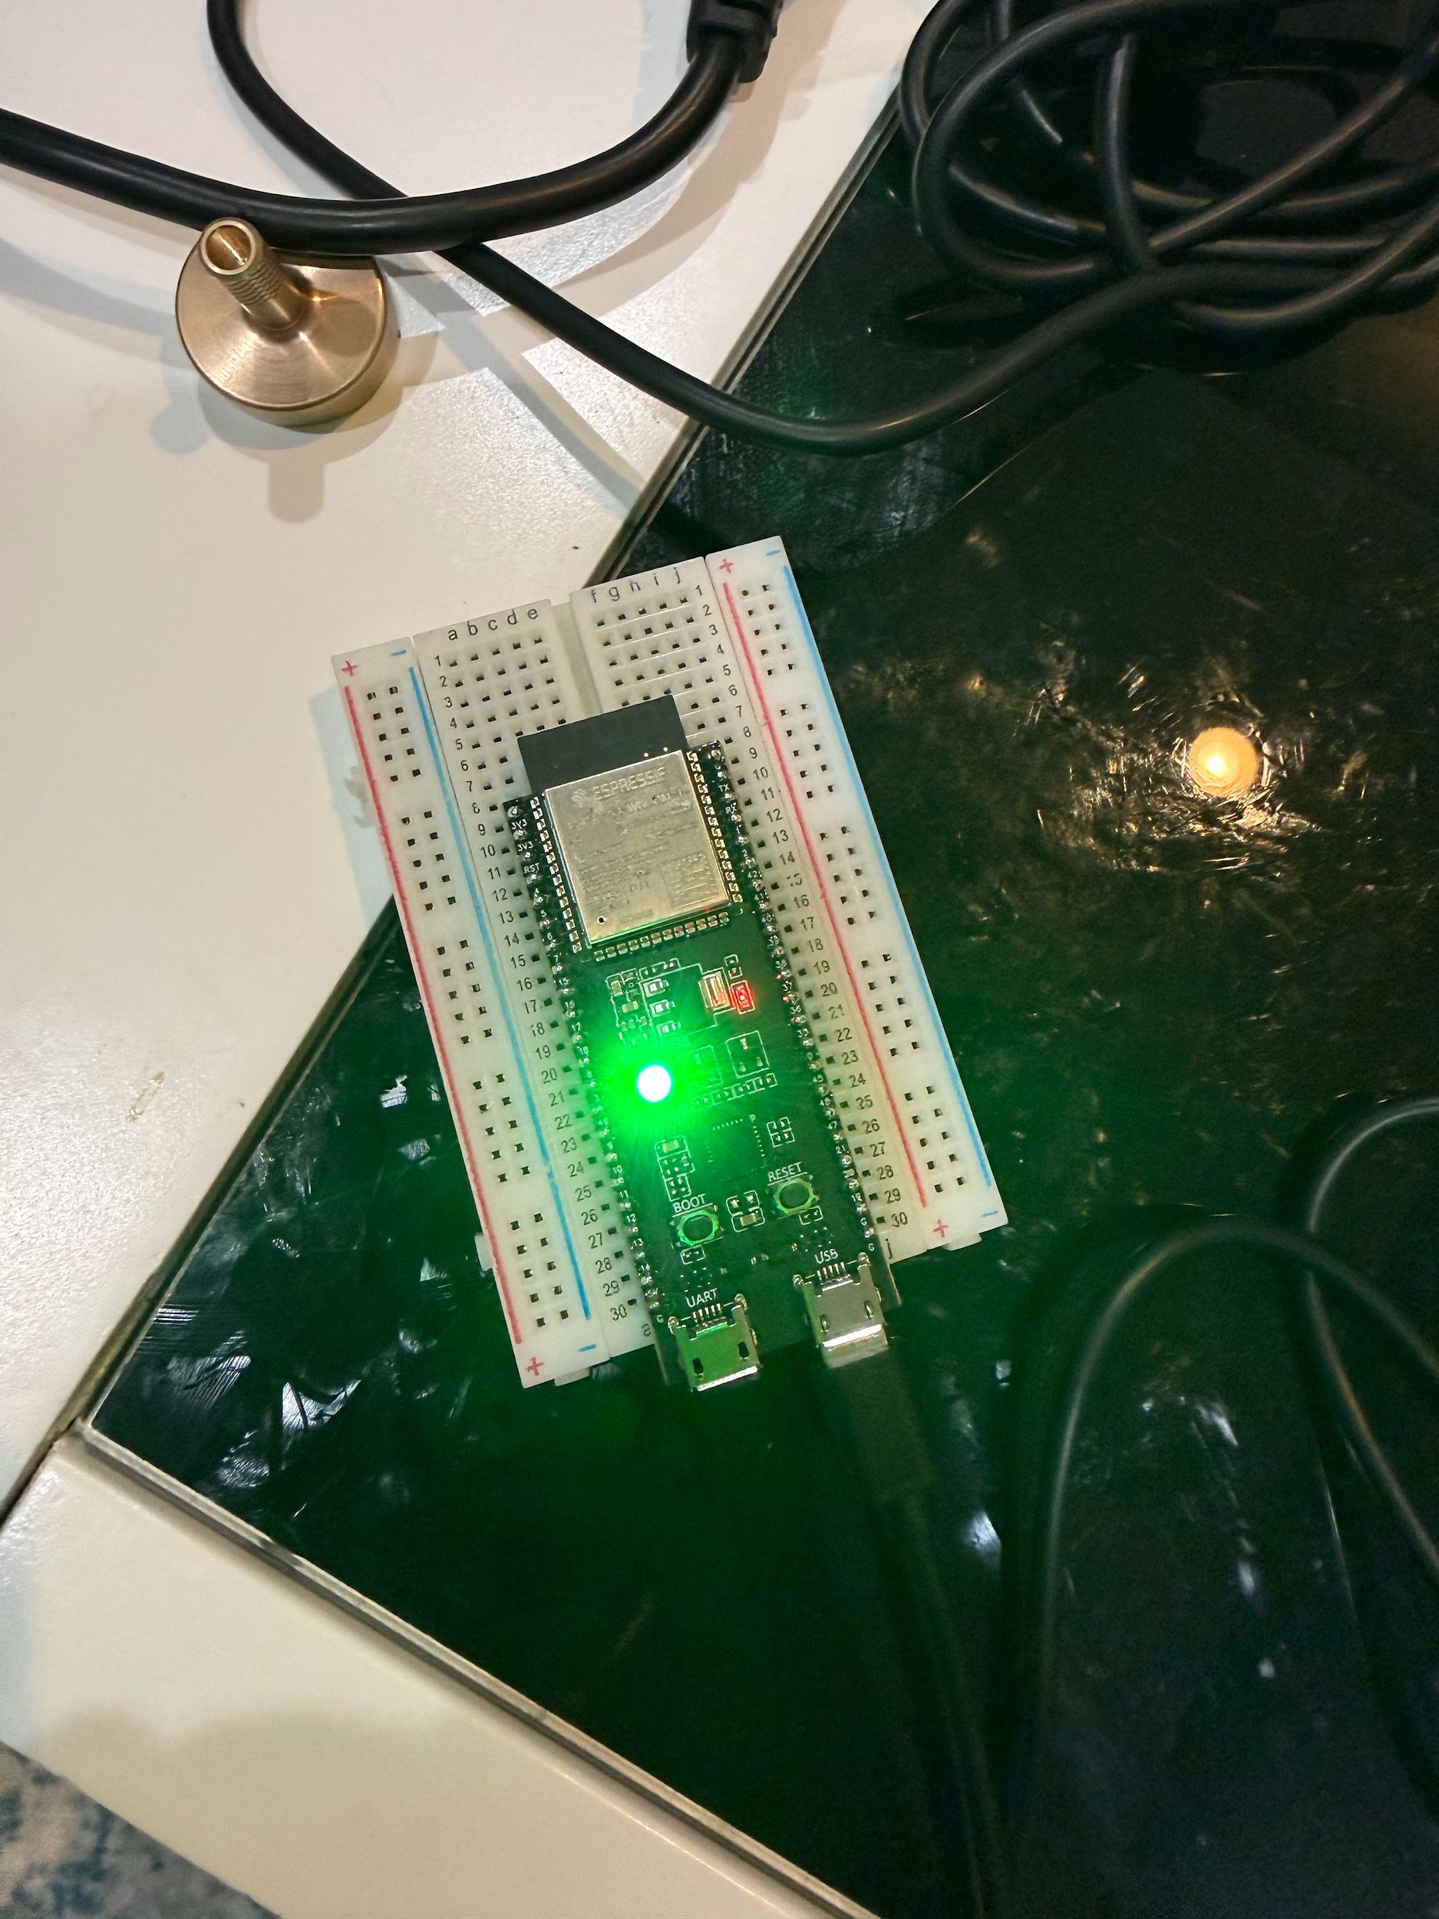

(without connecting) (after connecting)

Test 2
- This test was done with “full” functionality (for this POC prototype)
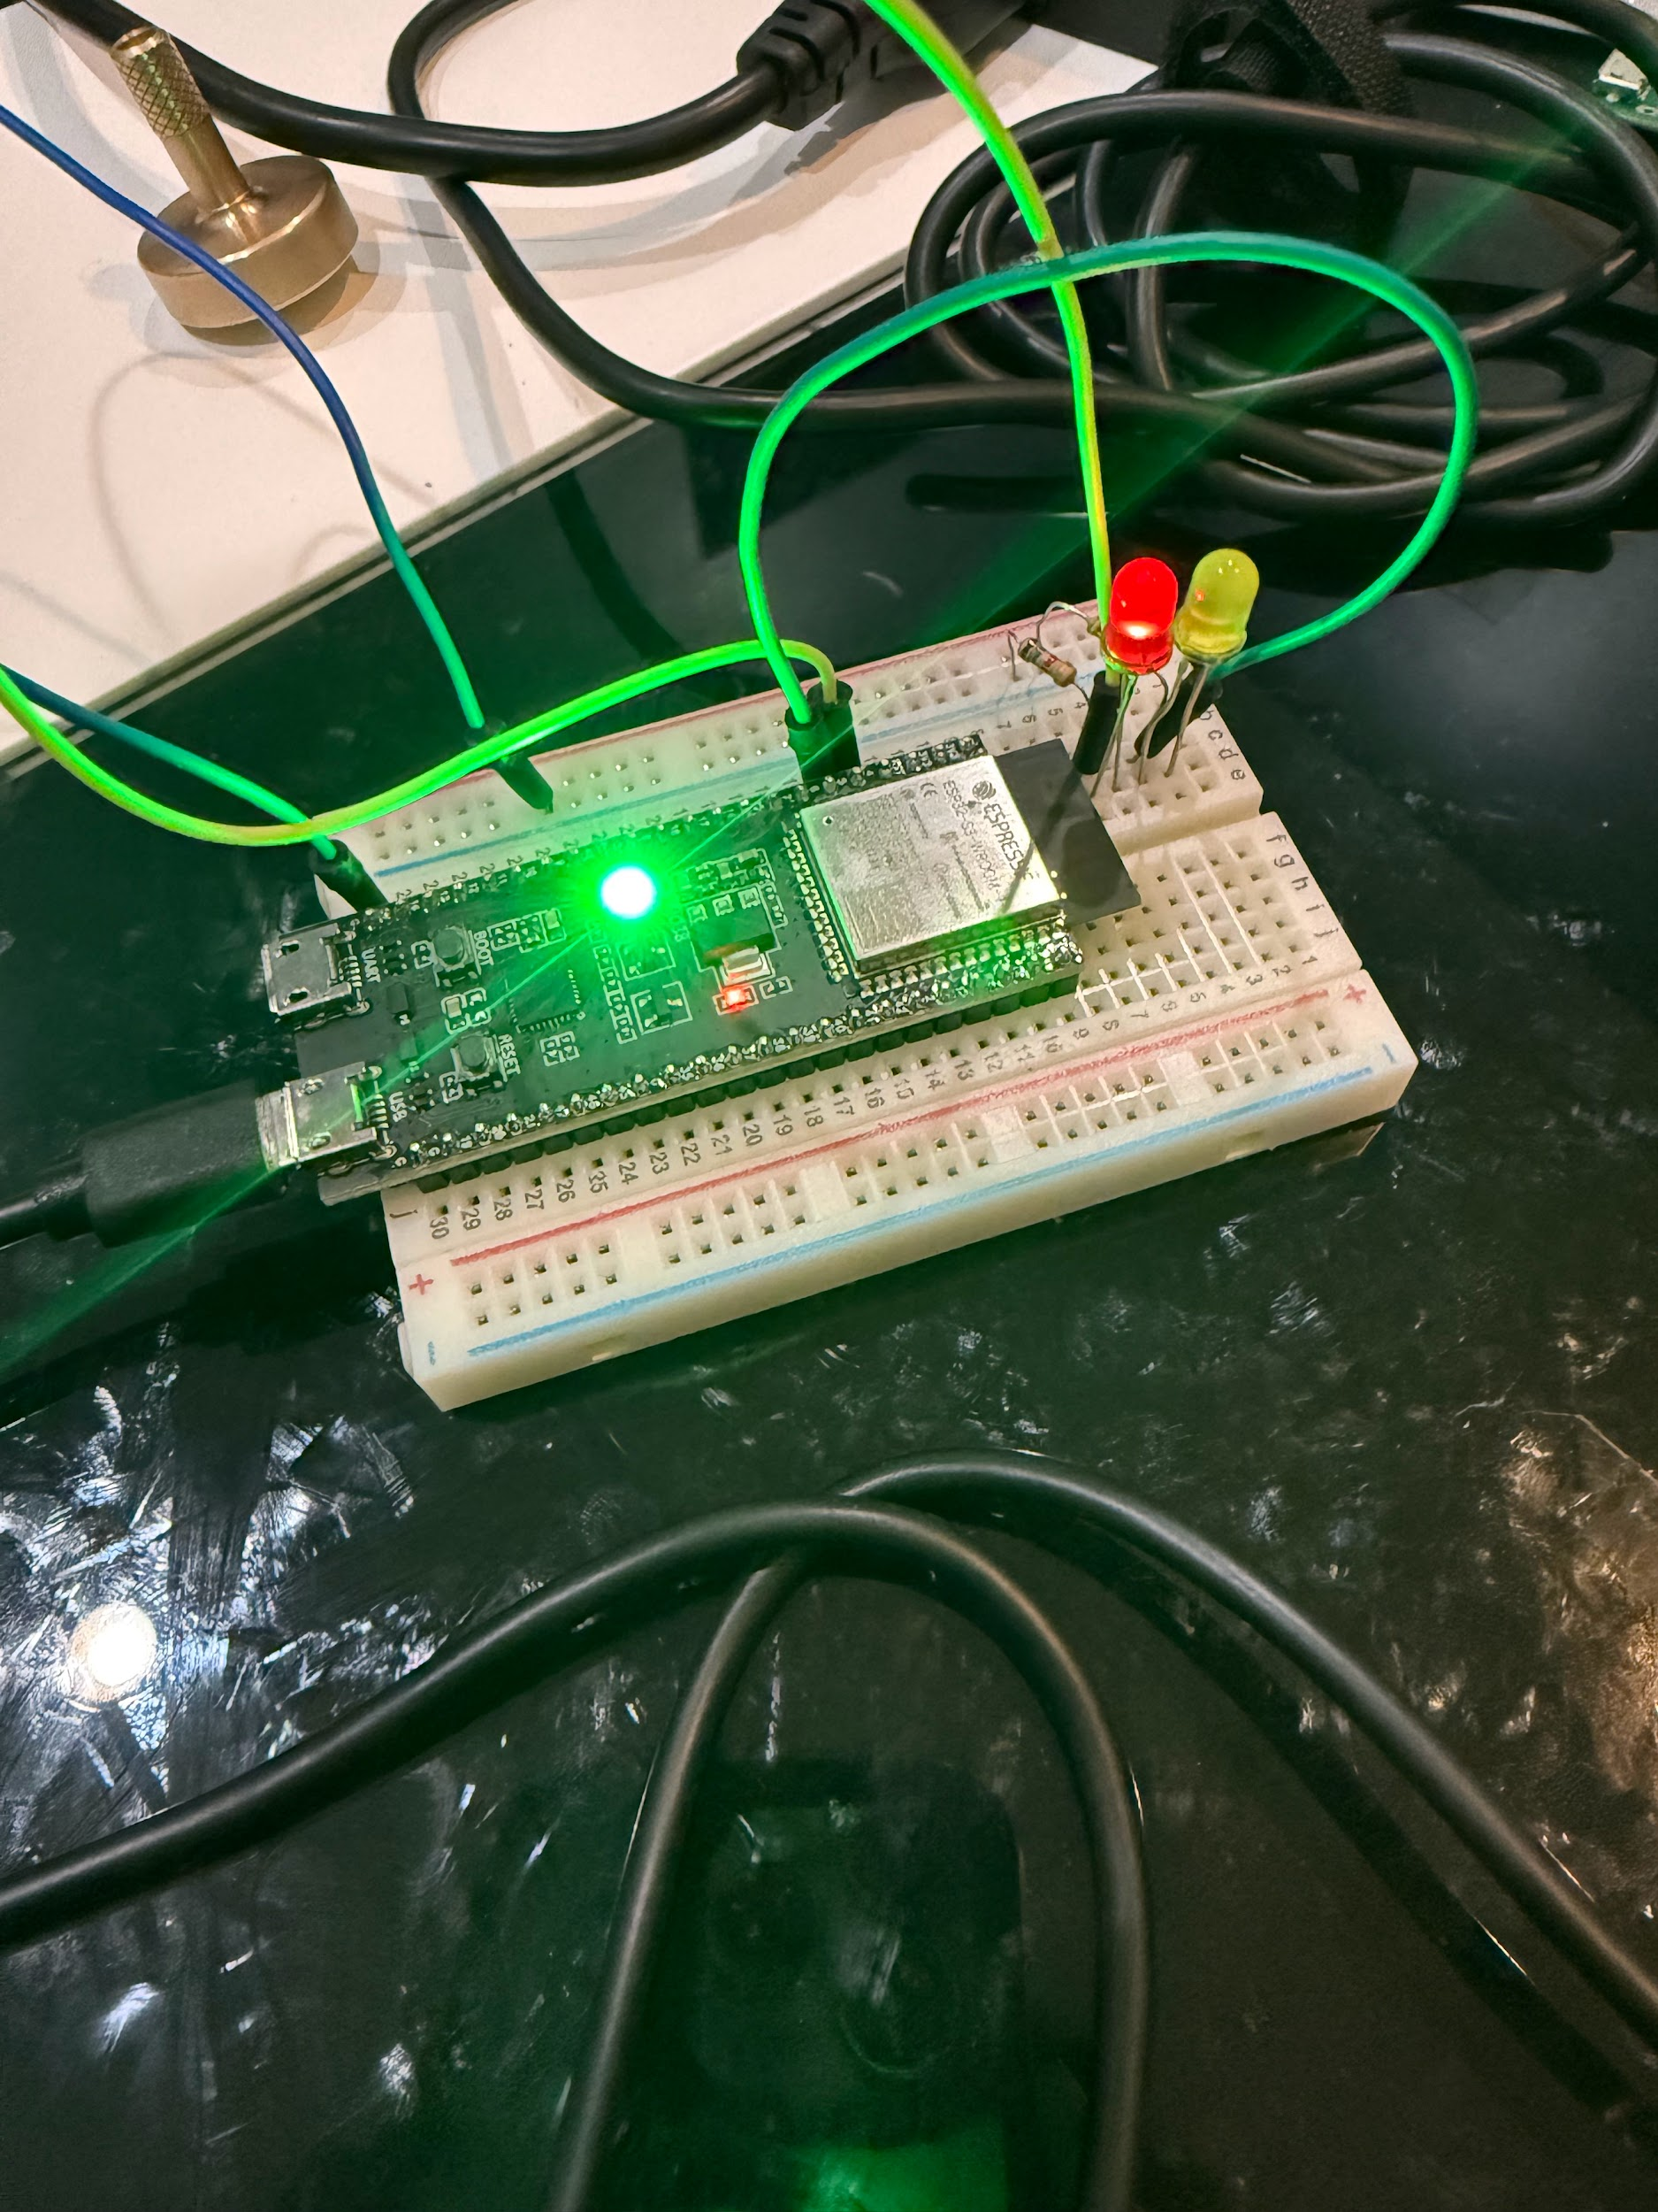
- LEDs indicate locked or unlocked status, as well as bluetooth connection status (still the built in LED)
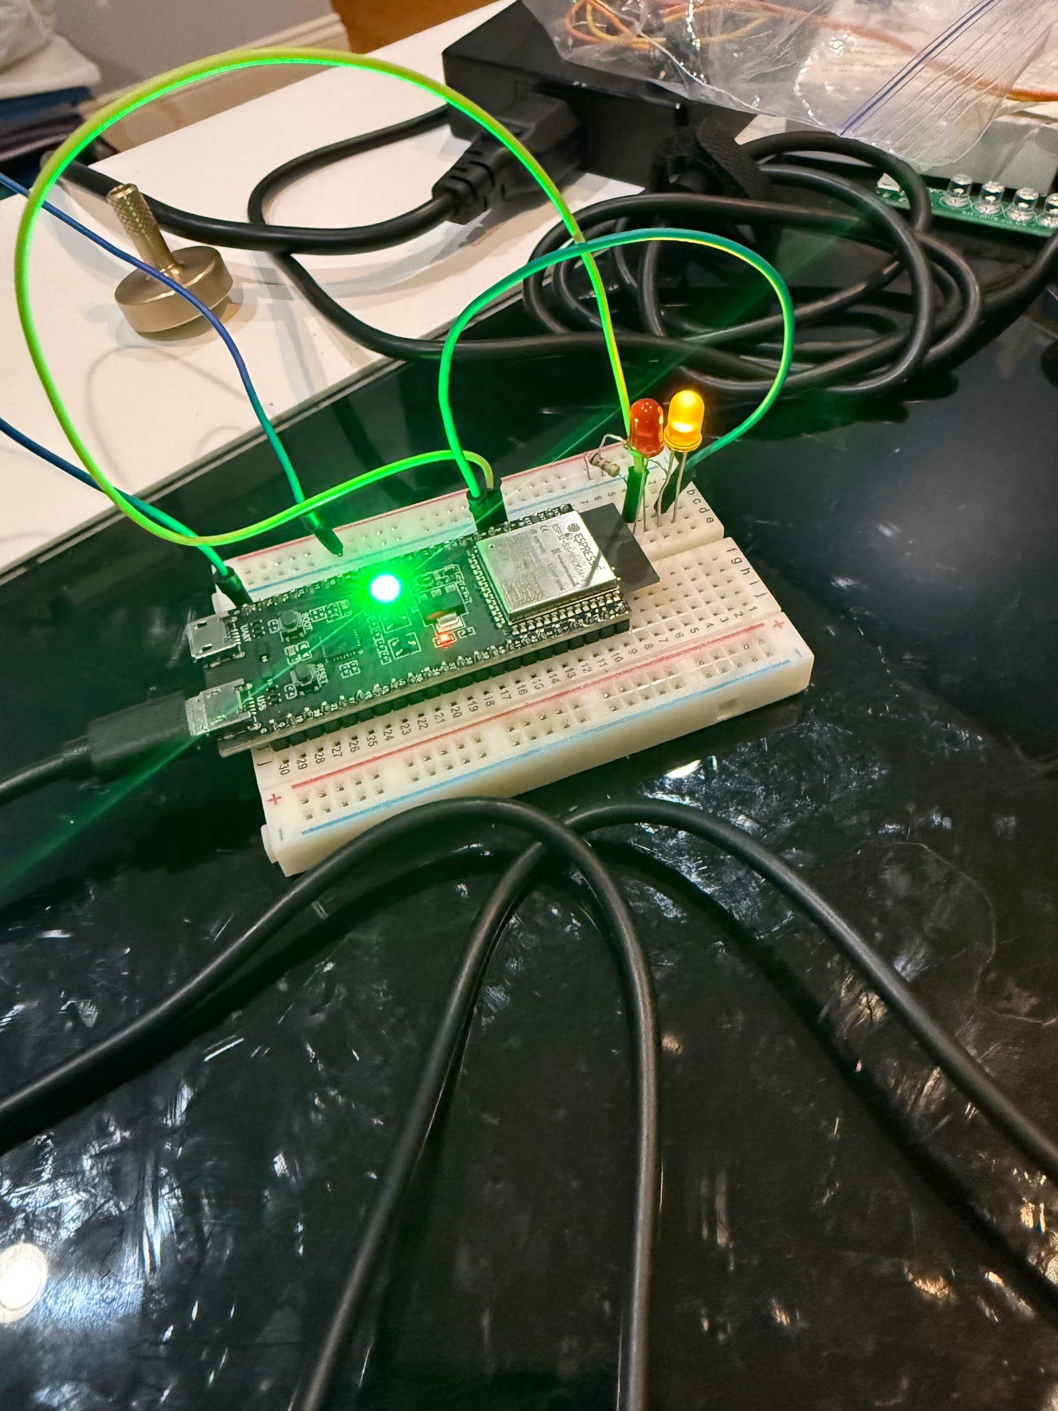

(device connected, unlocked [yellow on]) (device connected, locked [red on])

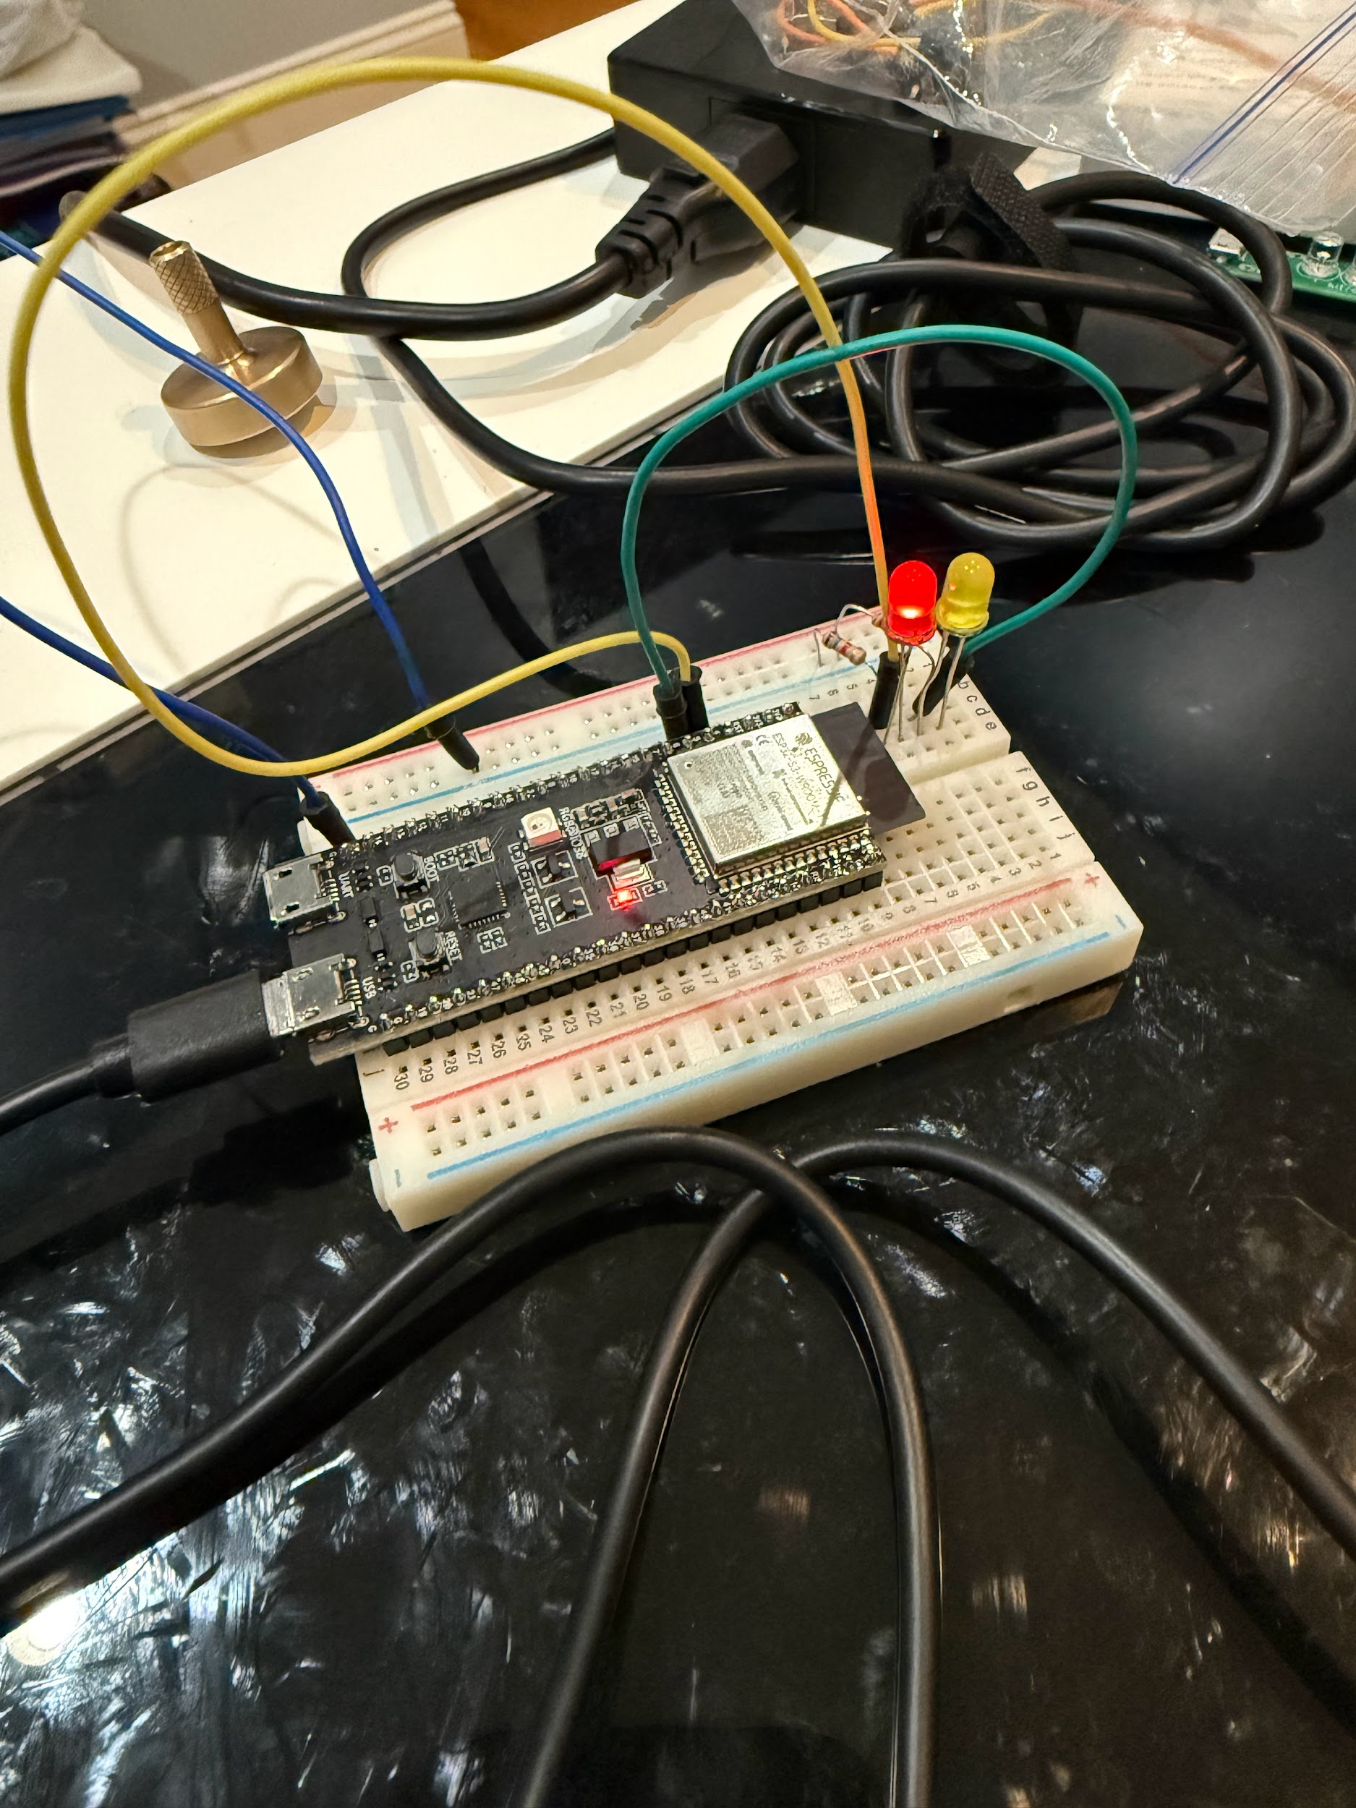

Here, we can see how the lock remains locked even when the device is disconnected (red LED on, built-in LED off)

